GL and Budget vs. Actuals Markdown File

How to use this document
This markdown file will use the DHCD Finance dept documents that are for reporting expenditures and GL data.
The data is collected from Workday. I will be referring to each of the code chunks (the code chunk refers to anything that is located within the ```{r} ``` area) within the file and add more detailed information on how to complete each of the r code chunk actions.
Follow along with the rmarkdown file named All_Service_Centers_GL_and_Budget_vs_Actuals or Summer_food_program_Gl_and_Budget_vs_Actuals.

IMPORTANT!!
- Download the raw data from Workday and rename the files according to below:
  - Example: gl_file_name <- "GL-Operating Actual Expenses YTD 2024-12-19.xlsx"
    - Change the date accordingly
  - Example: budg_vs_act_file_name <- "Budget_vs_Actuals_-_BBMR YTD 2024-12-19.xlsx"
    - Change the date accordingly
- Take note of the spaces in the names and make sure they are exactly as we have them here.
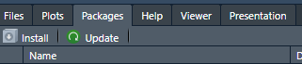

Libraries/Packages
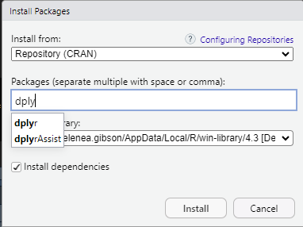
Libraries – It important to read in the libraries before you can start working or else the code will not run.
Some of the libraries may not be installed which will resort in an error upon reading.
If that is the case, then make sure to install packages using the packages tab at the bottom of the page > click install > type in the package name > and then run it.

Using the R markdown file
Ensure that all the packages are installed on the local drive – which is your personally drive- and then begin to run the data accordingly. Do not skip any lines, run it all in sequence. Once everything is ran and good to go, you can send the final document to those who need it via Sharepoint or email.

